1. Background
   1. You don't need to submit any screenshots for the Background section.
   2. Familiarize yourself with Docker Playground: <https://labs.play-with-docker.com/>
   3. Familiarize yourself with Kubernetes Playground: <https://labs.play-with-k8s.com/>
2. Docker
   1. Go through the Python exercise in <https://docs.docker.com/language/python/>
   2. This teaches you how to create a containerized Python application using Docker. Do all the steps of this tutorial except for the last step "Deploy your app". You will do this step in the Kubernetes section.
   3. Take screenshots of each step and paste them into a Microsoft Word document entitled Docker-K8s-Lab.doc under a Docker section
3. Kubernetes
   1. Install Kubernetes on your laptop. You can either use Minikube (<https://minikube.sigs.k8s.io/docs/start/>) or Docker Desktop (you will need to follow the instructions to enable Kubernetes).
   2. Go through the exercises in <https://kubernetes.io/docs/tutorials/kubernetes-basics/>
   3. Deploy the Flask app you built in the Docker section on your cluster. Your deployment should have 2 pods and your service can use ClusterIP or NodePort.
   4. Take screenshots of each step and paste them into a separate K8s section in the doc Docker-K8s-Lab.doc.
   5. Submit the document using file upload option in this assignment.

**Docker**

**Containerize a Python application:**

**Prerequisites**

You have installed the latest version of Docker Desktop.

You have a git client. The examples in this section use a command-line based git client, but you can use any client.

**Overview**

This section walks you through containerizing and running a Python application.

**Get the sample application**

The sample application uses the popular Flask framework.

Clone the sample application to use with this guide. Open a terminal, change directory to a directory that you want to work in, and run the following command to clone the repository:

|  |
| --- |
| $ git clone https://github.com/docker/python-docker |

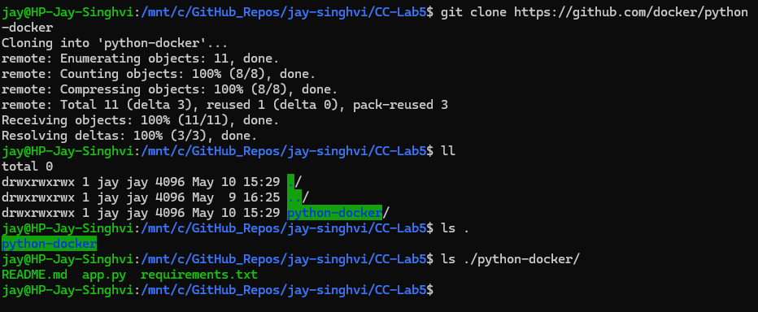

**Initialize Docker assets**

Now that you have an application, you can use docker init to create the necessary Docker assets to containerize your application. Inside the python-docker directory, run the docker init command. docker init provides some default configuration, but you'll need to answer a few questions about your application. For example, this application uses Flask to run. Refer to the following example to answer the prompts from docker init and use the same answers for your prompts.

|  |
| --- |
| $ docker init  Welcome to the Docker Init CLI!  This utility will walk you through creating the following files with sensible defaults for your project:  - .dockerignore  - Dockerfile  - compose.yaml  - README.Docker.md  Let's get started!  ? What application platform does your project use? Python  ? What version of Python do you want to use? 3.11.4  ? What port do you want your app to listen on? 5000  ? What is the command to run your app? python3 -m flask run --host=0.0.0.0 |

You should now have the following contents in your python-docker directory.

|  |
| --- |
| ├── python-docker/  │ ├── app.py  │ ├── requirements.txt  │ ├── .dockerignore  │ ├── compose.yaml  │ ├── Dockerfile  │ ├── README.Docker.md  │ └── README.md |

To learn more about the files that docker init added, see the following:

|  |
| --- |
| Dockerfile  .dockerignore  compose.yaml |

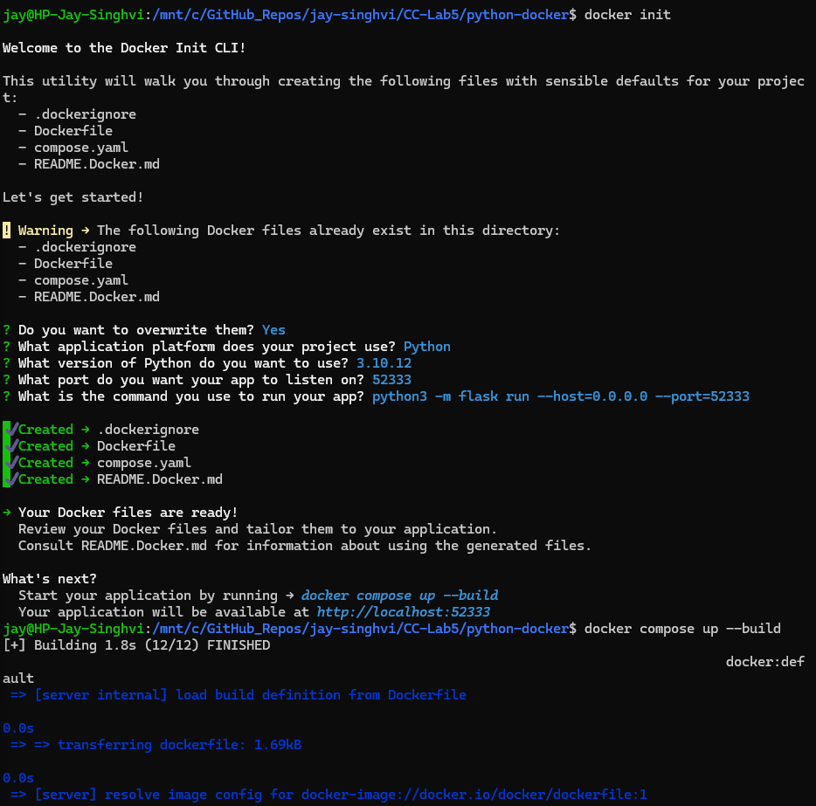

**Command =** python3 —m flask run -—host=0.0.0.0 -—port=52333

**Run the application**

Inside the python-docker directory, run the following command in a terminal.

|  |
| --- |
| $ docker compose up --build |

Open a browser and view the application at http://localhost:5000. You should see a simple Flask application.

In the terminal, press ctrl+c to stop the application.

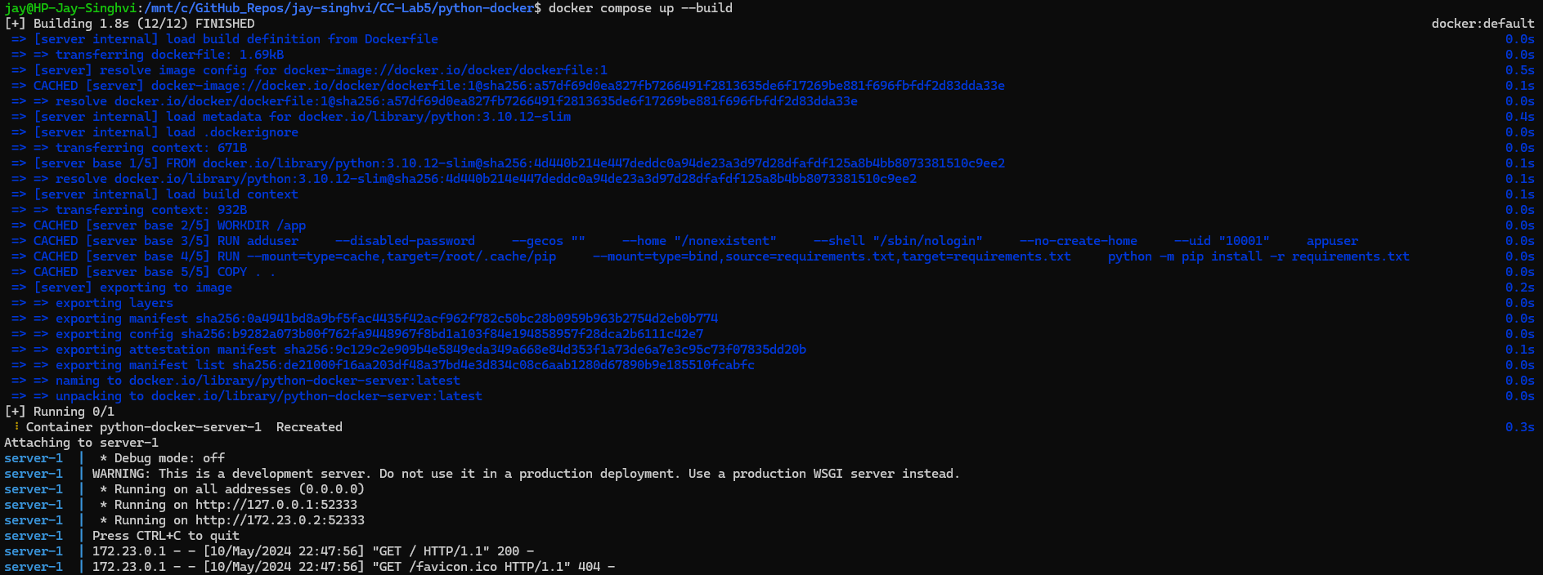

**Run the application in the background**

You can run the application detached from the terminal by adding the -d option. Inside the python-docker directory, run the following command in a terminal.

|  |
| --- |
| $ docker compose up --build -d |

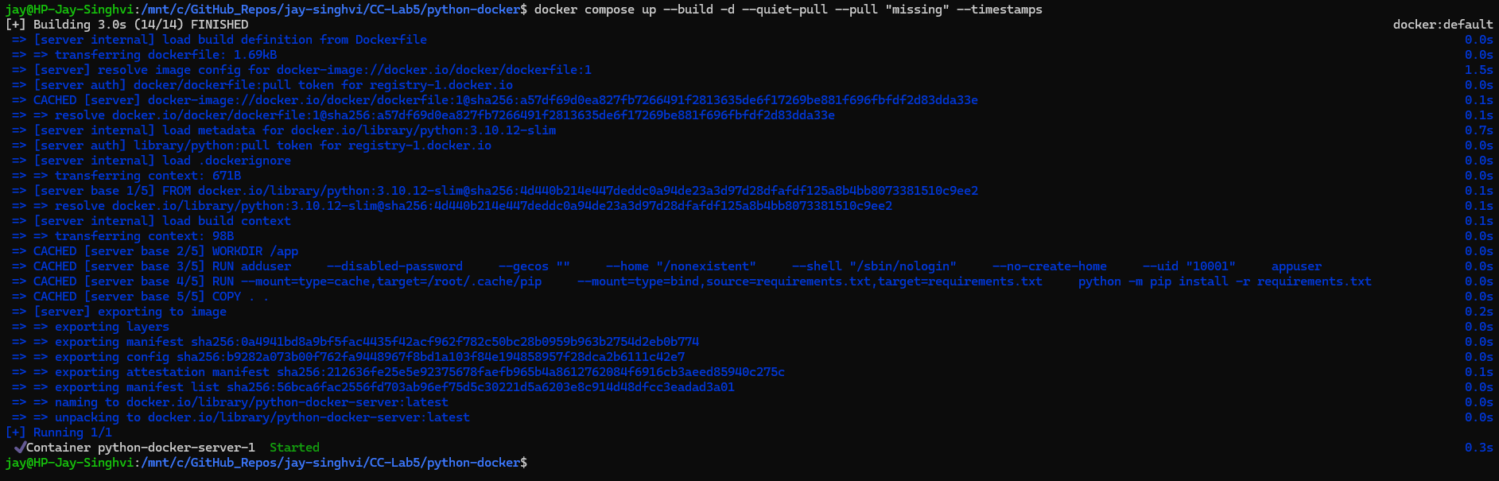

Open a browser and view the application at http://localhost:5000.

You should see a simple Flask application.

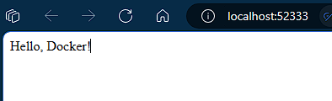

In the terminal, run the following command to stop the application.

|  |
| --- |
| $ docker compose down |

For more information about Compose commands, see the Compose CLI reference.

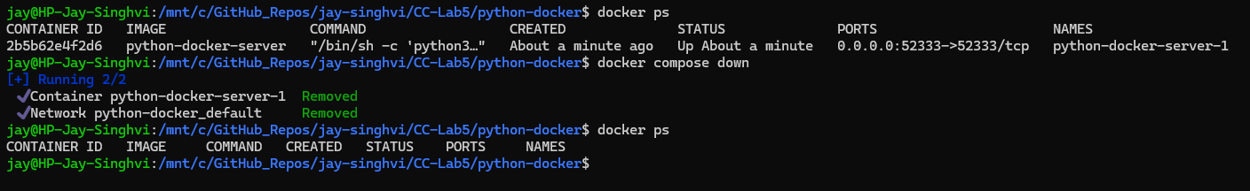

**Use containers for Python development**

**Prerequisites**

Complete Containerize a Python application.

**Overview**

In this section, you'll learn how to set up a development environment for your containerized application. This includes:

Adding a local database and persisting data

Configuring Compose to automatically update your running Compose services as you edit and save your code

**Get the sample application**

You'll need to clone a new repository to get a sample application that includes logic to connect to the database.

Change to a directory where you want to clone the repository and run the following command.

|  |
| --- |
| git clone https://github.com/docker/python-docker-dev |

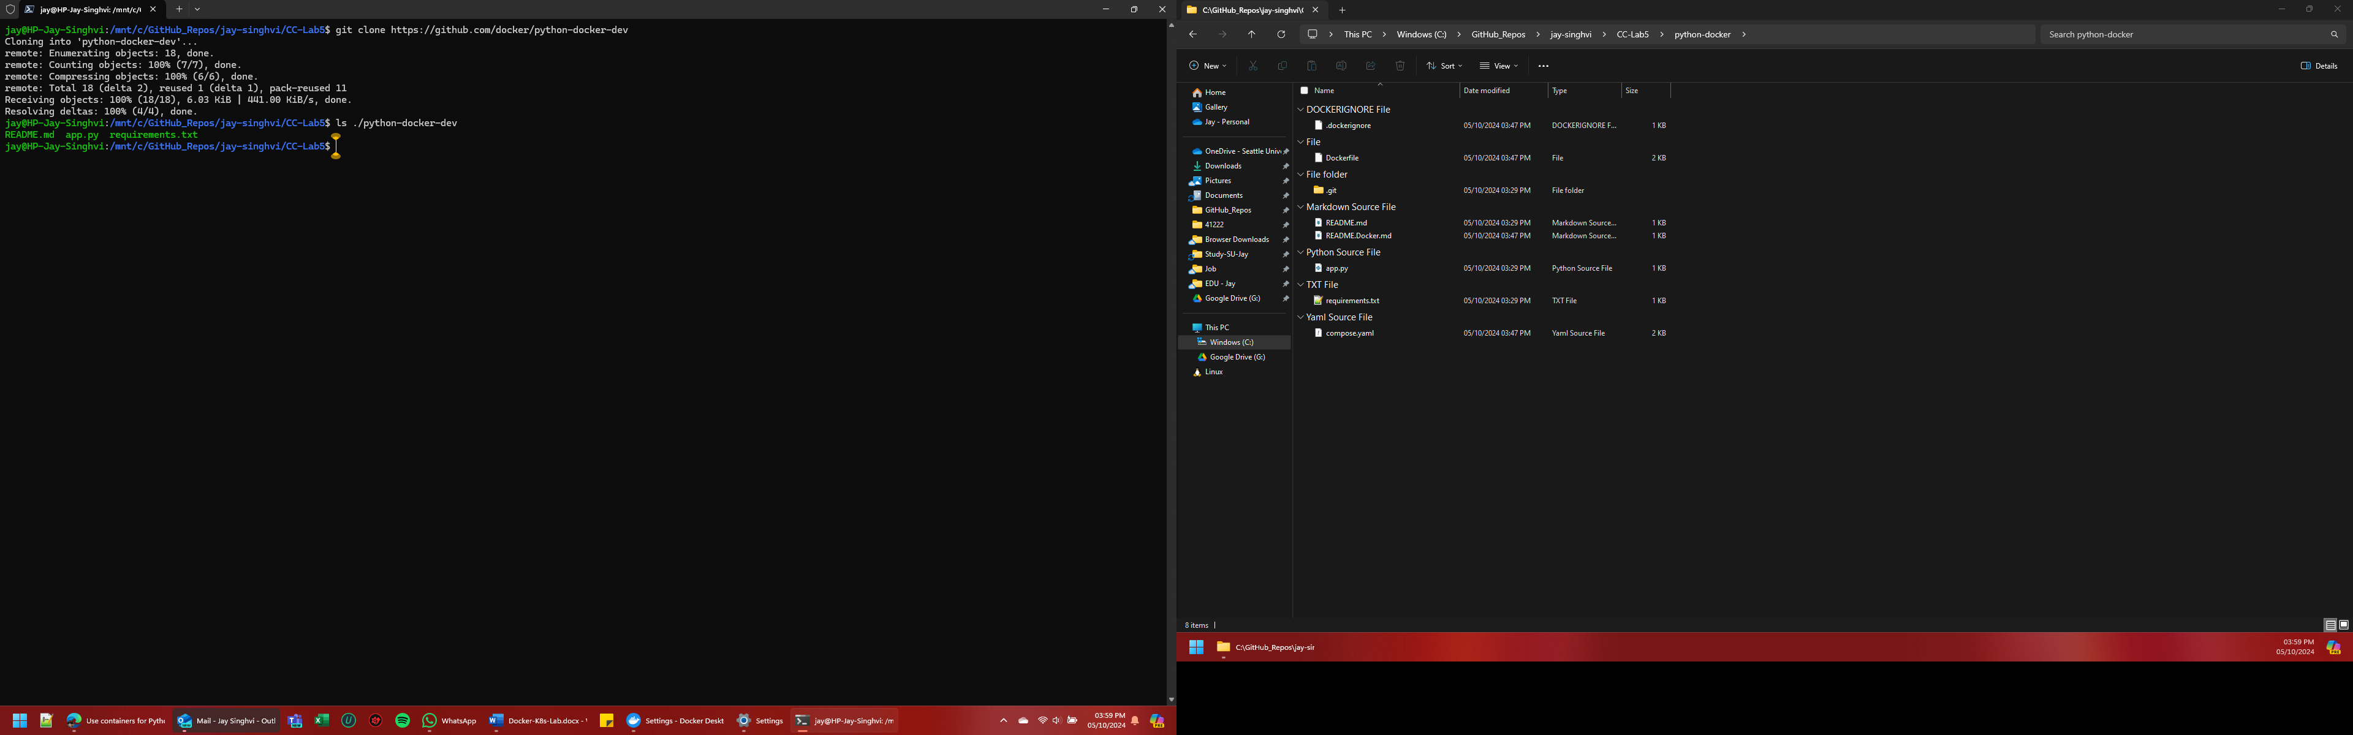

In the cloned repository's directory, run docker init to create the necessary Docker files. Refer to the following example to answer the prompts from docker init.

|  |
| --- |
| docker init  Welcome to the Docker Init CLI!  This utility will walk you through creating the following files with sensible defaults for your project:  - .dockerignore  - Dockerfile  - compose.yaml  - README.Docker.md  Let's get started!  ? What application platform does your project use? Python  ? What version of Python do you want to use? 3.11.4  ? What port do you want your app to listen on? 5000  ? What is the command to run your app? python3 -m flask run --host=0.0.0.0 |

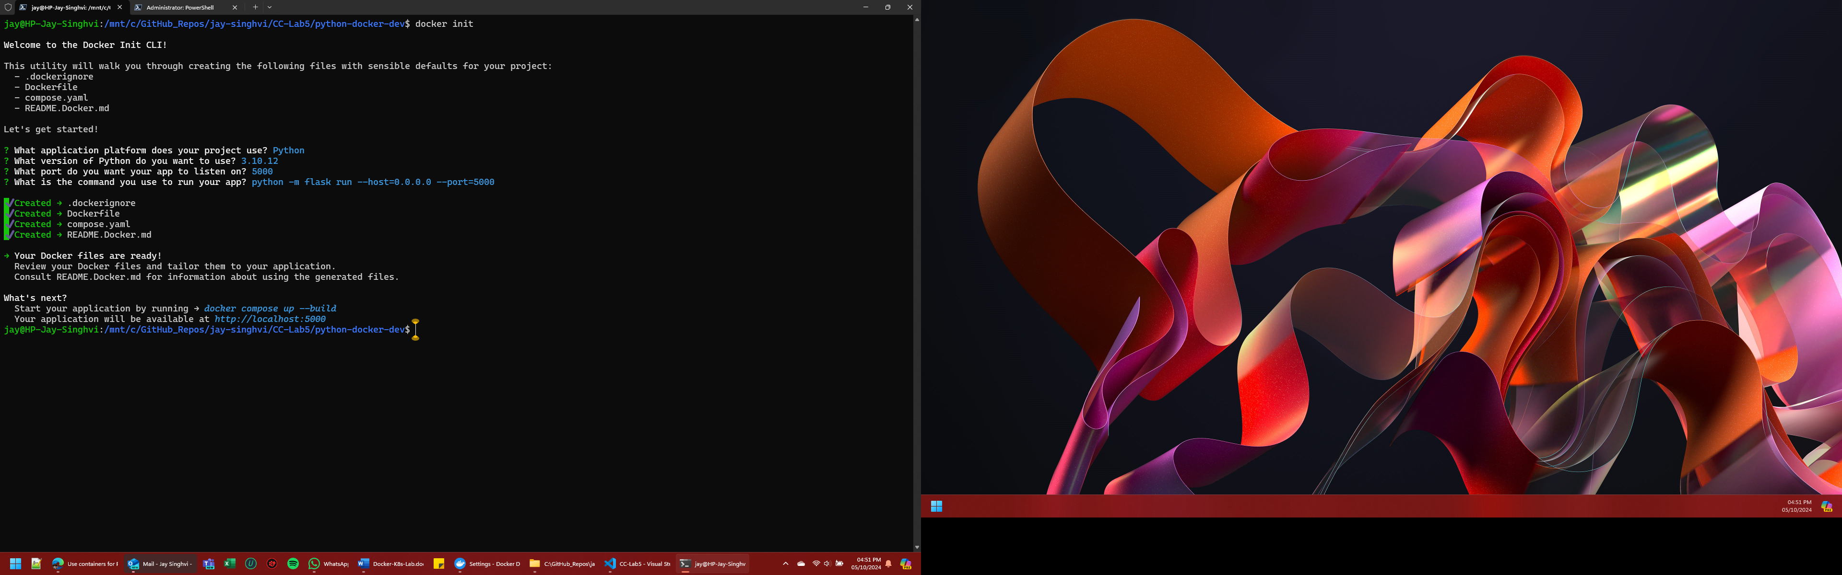

**Add a local database and persist data**

You can use containers to set up local services, like a database. In this section, you'll update the compose.yaml file to define a database service and a volume to persist data.

In the cloned repository's directory, open the compose.yaml file in an IDE or text editor. docker init handled creating most of the instructions, but you'll need to update it for your unique application.

In the compose.yaml file, you need to uncomment all of the database instructions. In addition, you need to add the database password file as an environment variable to the server service and specify the secret file to use .

The following is the updated compose.yaml file.

|  |
| --- |
| services:  server:  build:  context: .  ports:  - 5000:5000  environment:  - POSTGRES_PASSWORD_FILE=/run/secrets/db-password  depends_on:  db:  condition: service_healthy  secrets:  - db-password  db:  image: postgres  restart: always  user: postgres  secrets:  - db-password  volumes:  - db-data:/var/lib/postgresql/data  environment:  - POSTGRES_DB=example  - POSTGRES_PASSWORD_FILE=/run/secrets/db-password  expose:  - 5432  healthcheck:  test: [ "CMD", "pg_isready" ]  interval: 10s  timeout: 5s  retries: 5  volumes:  db-data:  secrets:  db-password:  file: db/password.txt |

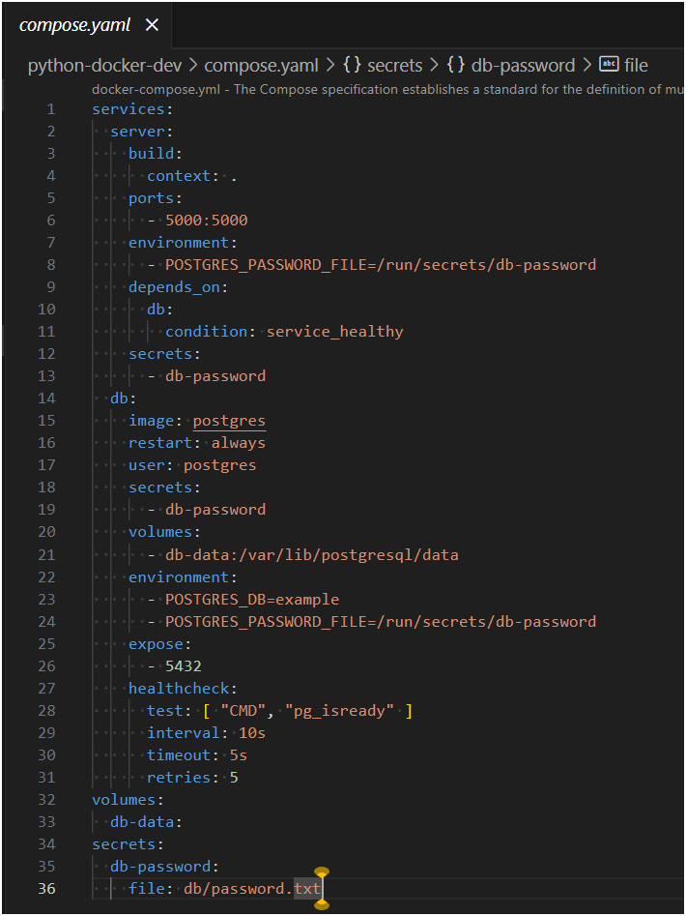

Before you run the application using Compose, notice that this Compose file specifies a password.txt file to hold the database's password. You must create this file as it's not included in the source repository.

In the cloned repository's directory, create a new directory named db and inside that directory create a file named password.txt that contains the password for the database. Using your favorite IDE or text editor, add the following contents to the password.txt file.

|  |
| --- |
| mysecretpassword |

Save and close the password.txt file.

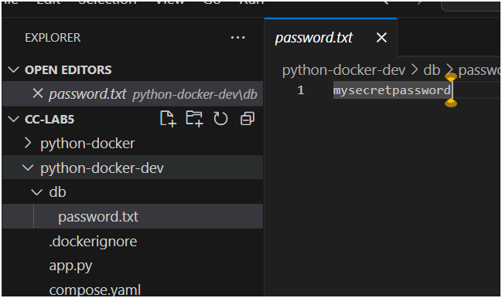

You should now have the following contents in your python-docker-dev directory.

|  |
| --- |
| ├── python-docker-dev/  │ ├── db/  │ │ └── password.txt  │ ├── app.py  │ ├── requirements.txt  │ ├── .dockerignore  │ ├── compose.yaml  │ ├── Dockerfile  │ ├── README.Docker.md  │ └── README.md |

Now, run the following docker compose up command to start your application.

|  |
| --- |
| docker compose up --build |

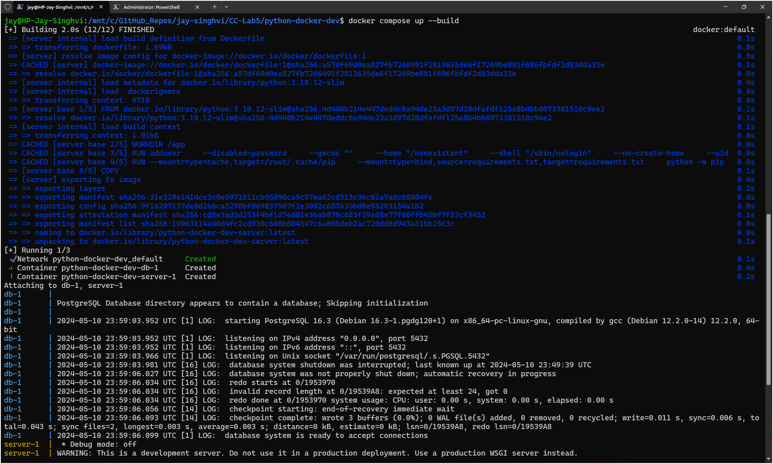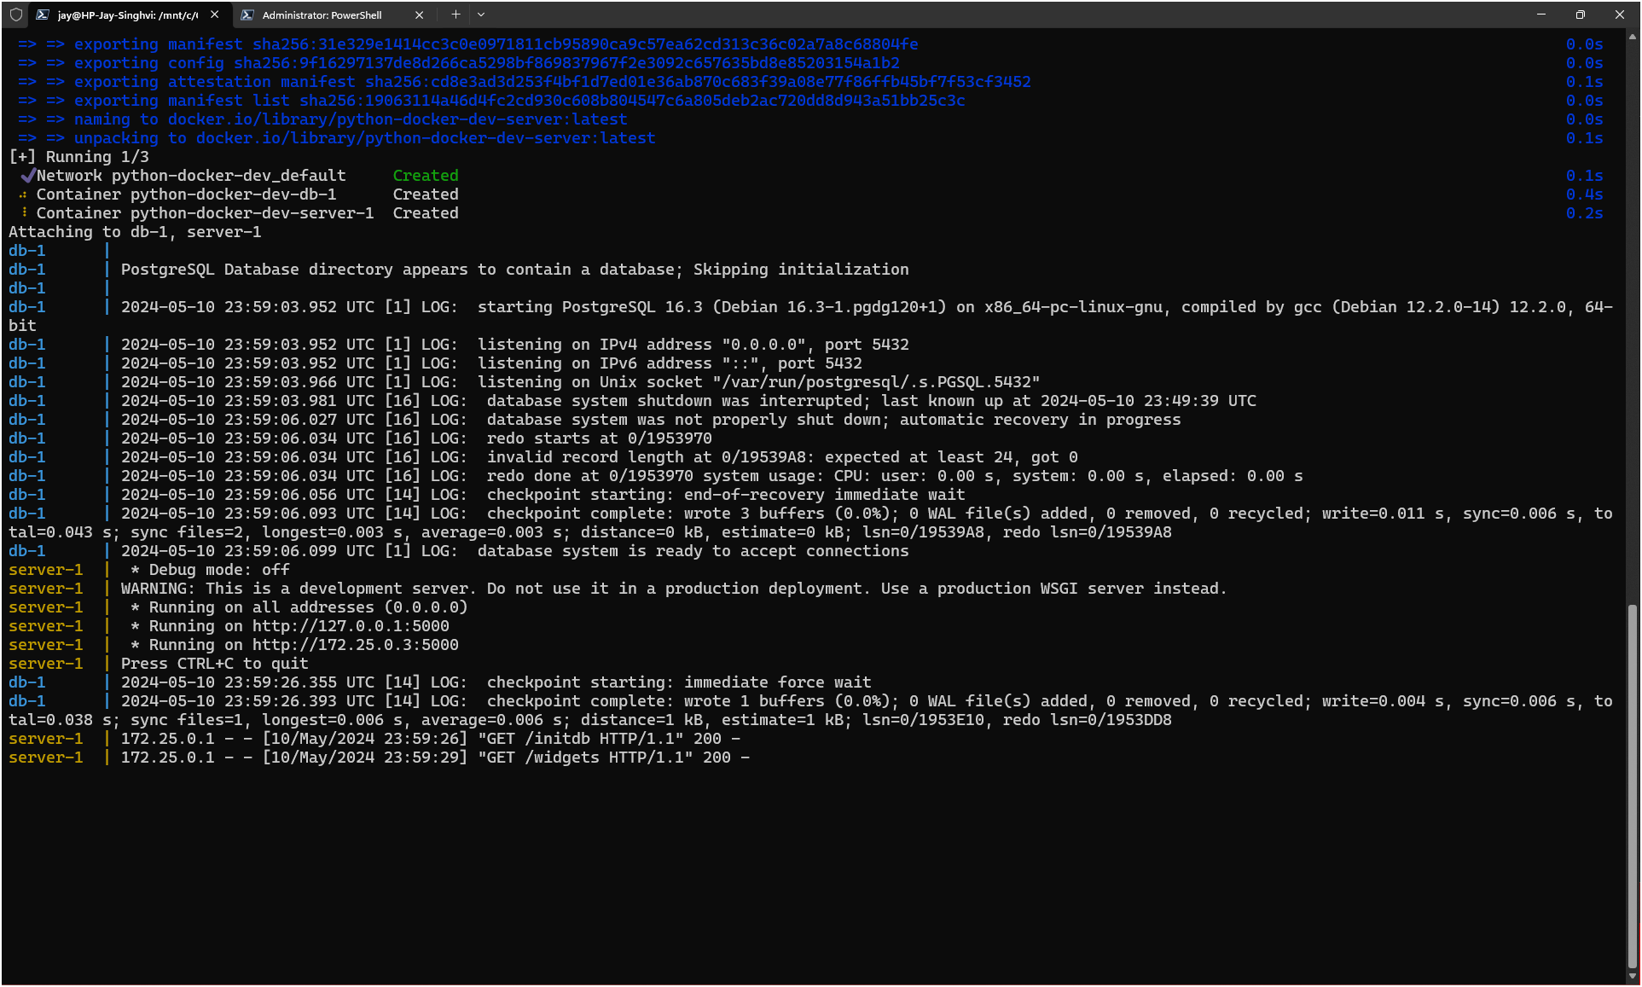

Now test your API endpoint. Open a new terminal then make a request to the server using the curl commands:

|  |
| --- |
| curl http://localhost:5000/initdb  curl http://localhost:5000/widgets |

You should receive the following response:

|  |
| --- |
| [] |

The response is empty because your database is empty.

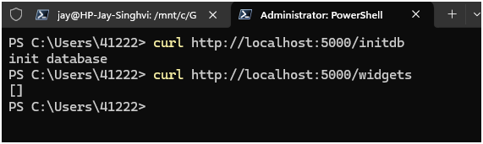

Press ctrl+c in the terminal to stop your application.

Automatically update services

Use Compose Watch to automatically update your running Compose services as you edit and save your code. For more details about Compose Watch, see Use Compose Watch.

Open your compose.yaml file in an IDE or text editor and then add the Compose Watch instructions. The following is the updated compose.yaml file.

|  |
| --- |
| services:  server:  build:  context: .  ports:  - 5000:5000  environment:  - POSTGRES_PASSWORD_FILE=/run/secrets/db-password  depends_on:  db:  condition: service_healthy  secrets:  - db-password  develop:  watch:  - action: rebuild  path: .  db:  image: postgres  restart: always  user: postgres  secrets:  - db-password  volumes:  - db-data:/var/lib/postgresql/data  environment:  - POSTGRES_DB=example  - POSTGRES_PASSWORD_FILE=/run/secrets/db-password  expose:  - 5432  healthcheck:  test: [ "CMD", "pg_isready" ]  interval: 10s  timeout: 5s  retries: 5  volumes:  db-data:  secrets:  db-password:  file: db/password.txt |

Run the following command to run your application with Compose Watch.

|  |
| --- |
| docker compose watch |

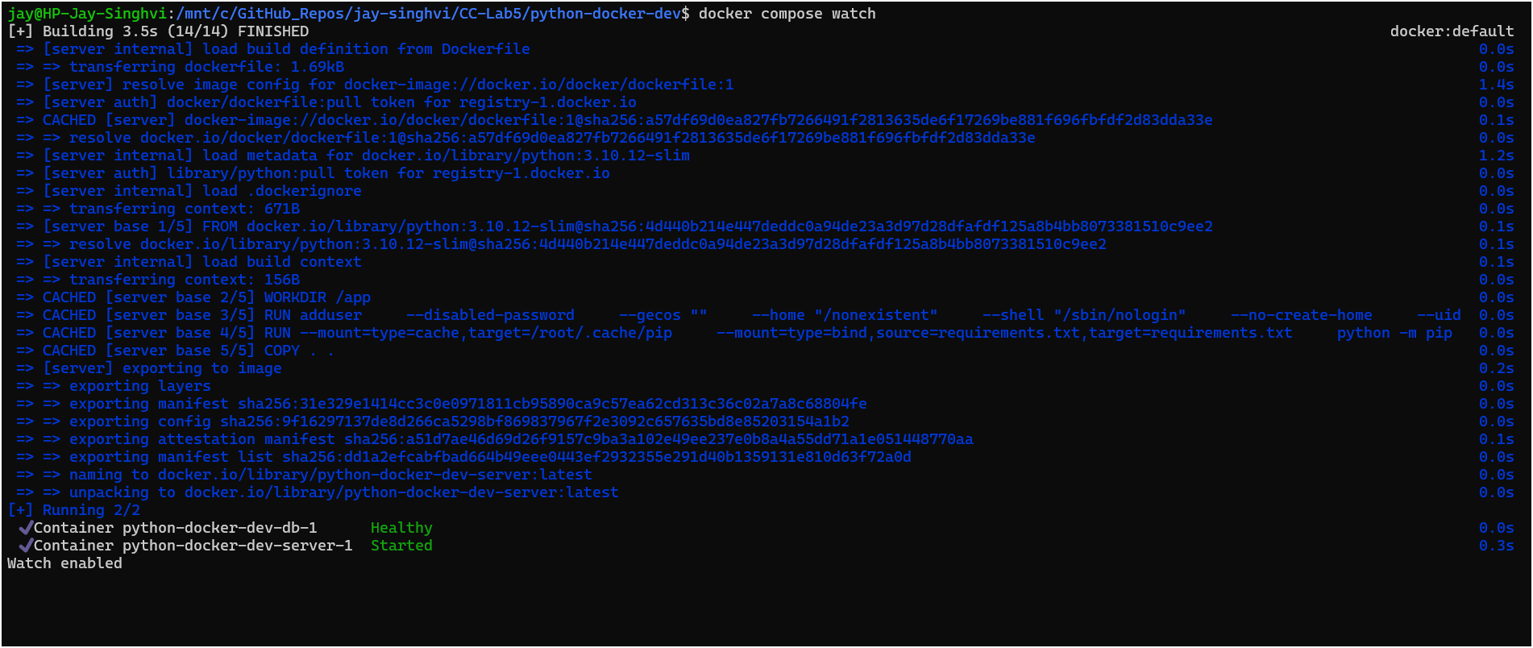

In a terminal, curl the application to get a response.

|  |
| --- |
| curl http://localhost:5000  Hello, Docker! |

Any changes to the application's source files on your local machine will now be immediately reflected in the running container.

Open python-docker-dev/app.py in an IDE or text editor and update the Hello, Docker! string by adding a few more exclamation marks.

|  |
| --- |
| - return 'Hello, Docker!'  + return 'Hello, Docker!!!' |

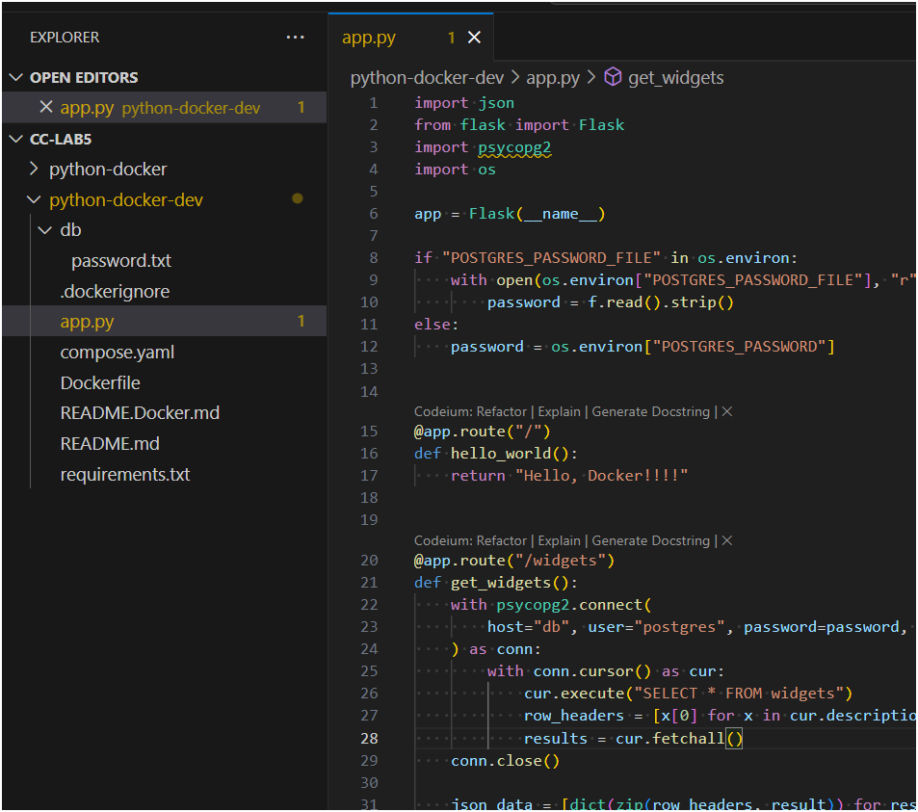

Save the changes to app.py and then wait a few seconds for the application to rebuild. Curl the application again and verify that the updated text appears.

|  |
| --- |
| curl http://localhost:5000  Hello, Docker!!! |

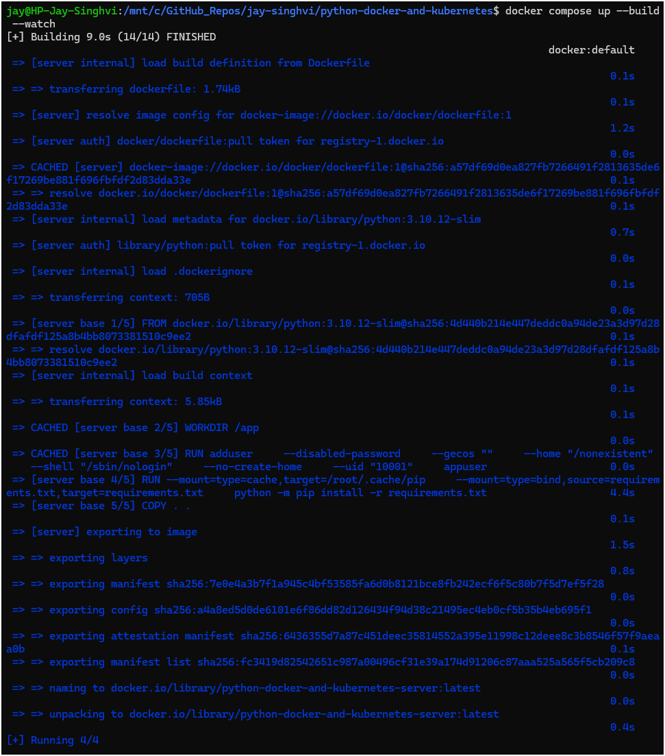

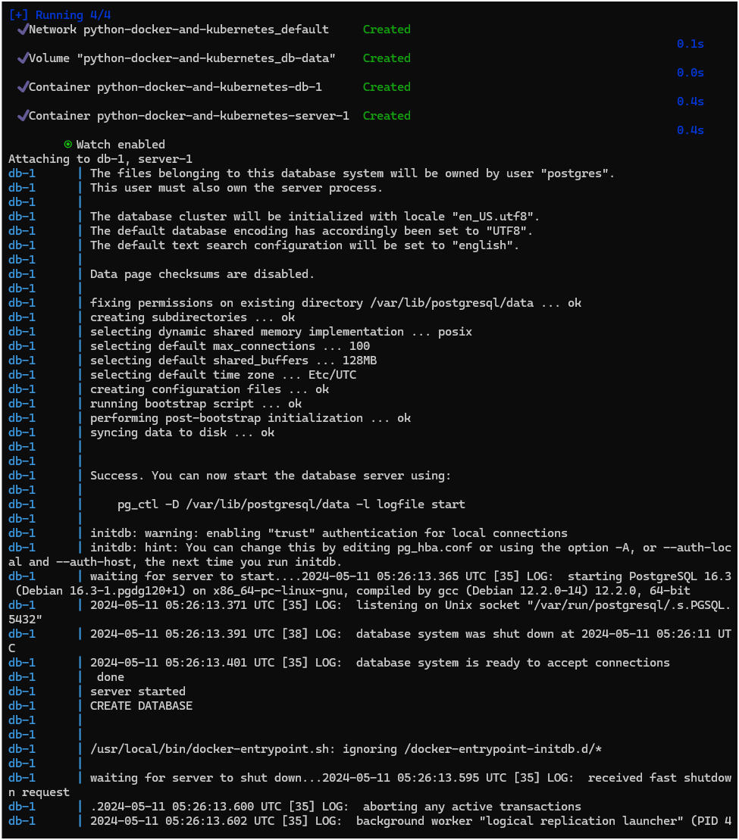

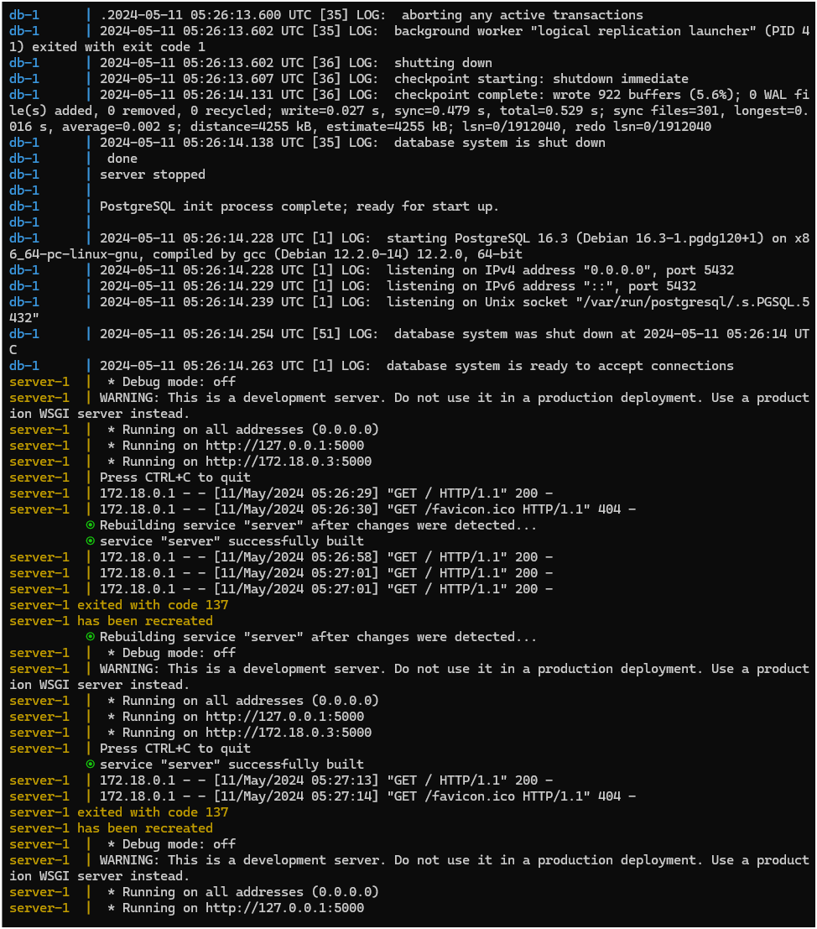

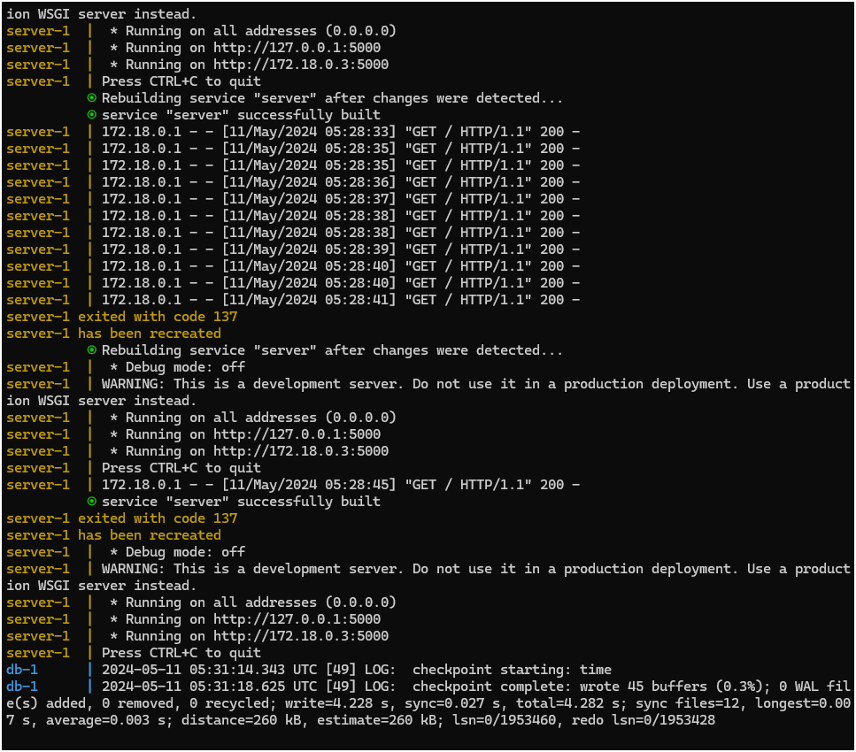

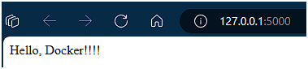

After change-

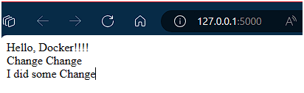

Press ctrl+c in the terminal to stop your application.

**Configure CI/CD for your Python application**

**Prerequisites**

Complete all the previous sections of this guide, starting with Containerize a Python application. You must have a GitHub account and a Docker account to complete this section.

**Overview**

In this section, you'll learn how to set up and use GitHub Actions to build and test your Docker image as well as push it to Docker Hub. You will complete the following steps:

1. Create a new repository on GitHub.
2. Define the GitHub Actions workflow.
3. Run the workflow.

**Step one: Create the repository**

Create a GitHub repository, configure the Docker Hub secrets, and push your source code.

1. Create a new repository on GitHub.
2. Open the repository Settings, and go to Secrets and variables > Actions.
3. Create a new secret named DOCKER_USERNAME and your Docker ID as value.
4. Create a new Personal Access Token (PAT) for Docker Hub. You can name this token python-docker.

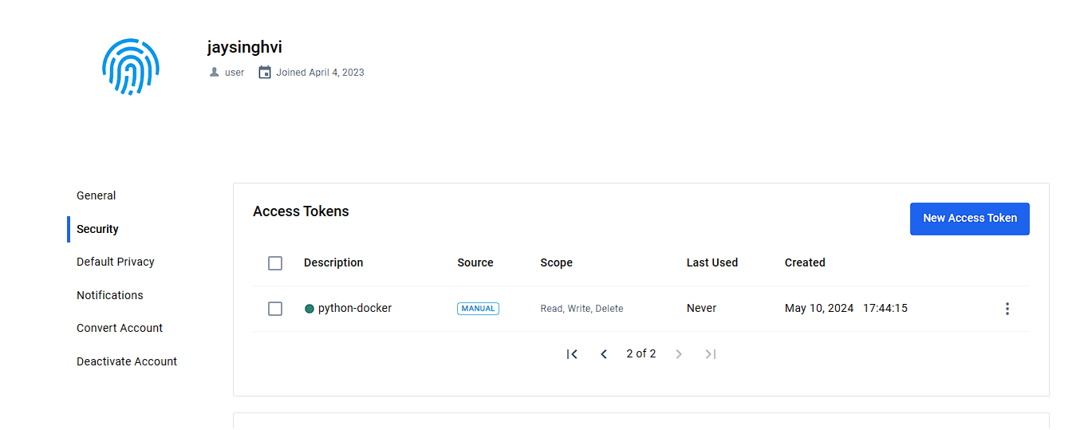

1. Add the PAT as a second secret in your GitHub repository, with the name DOCKERHUB_TOKEN.

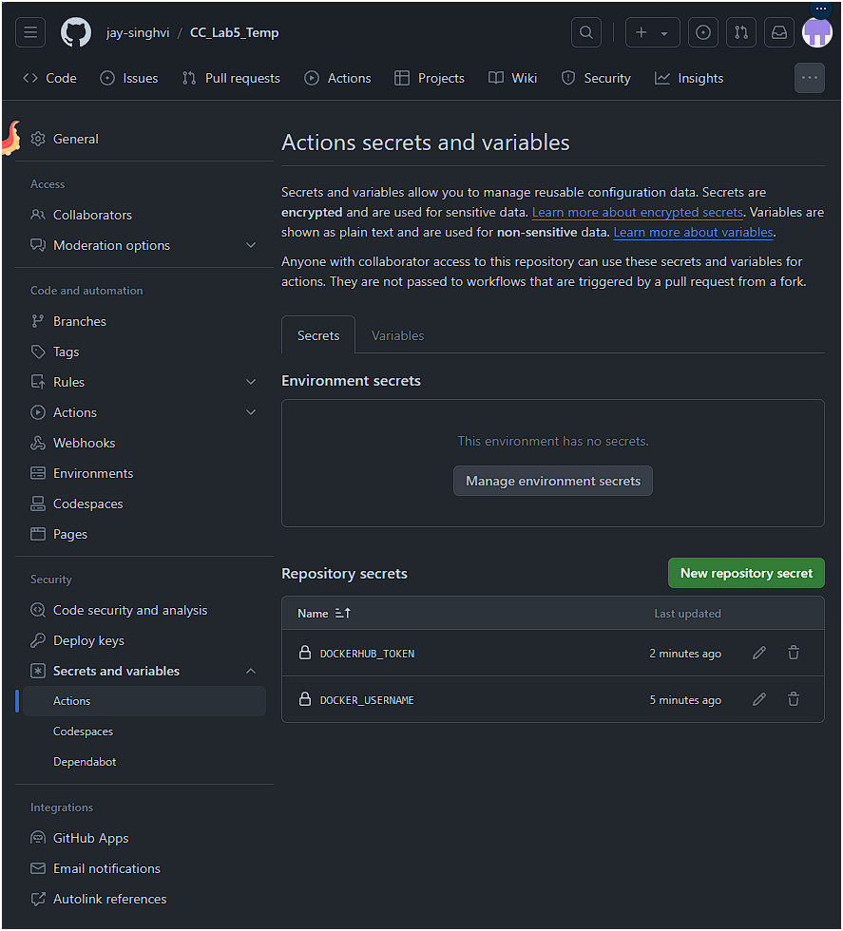

1. In your local repository on your machine, run the following command to change the origin to the repository you just created. Make sure you change your-username to your GitHub username and your-repository to the name of the repository you created.

|  |
| --- |
| git remote set-url origin https://github.com/your-username/your-repository.git |



1. Run the following commands to stage, commit, and push your local repository to GitHub.

|  |
| --- |
| git add -A  git commit -m "my commit"  git push -u origin main |

**## Note: These command does not work and gave below error and later the same was completed using VS Code GUI**

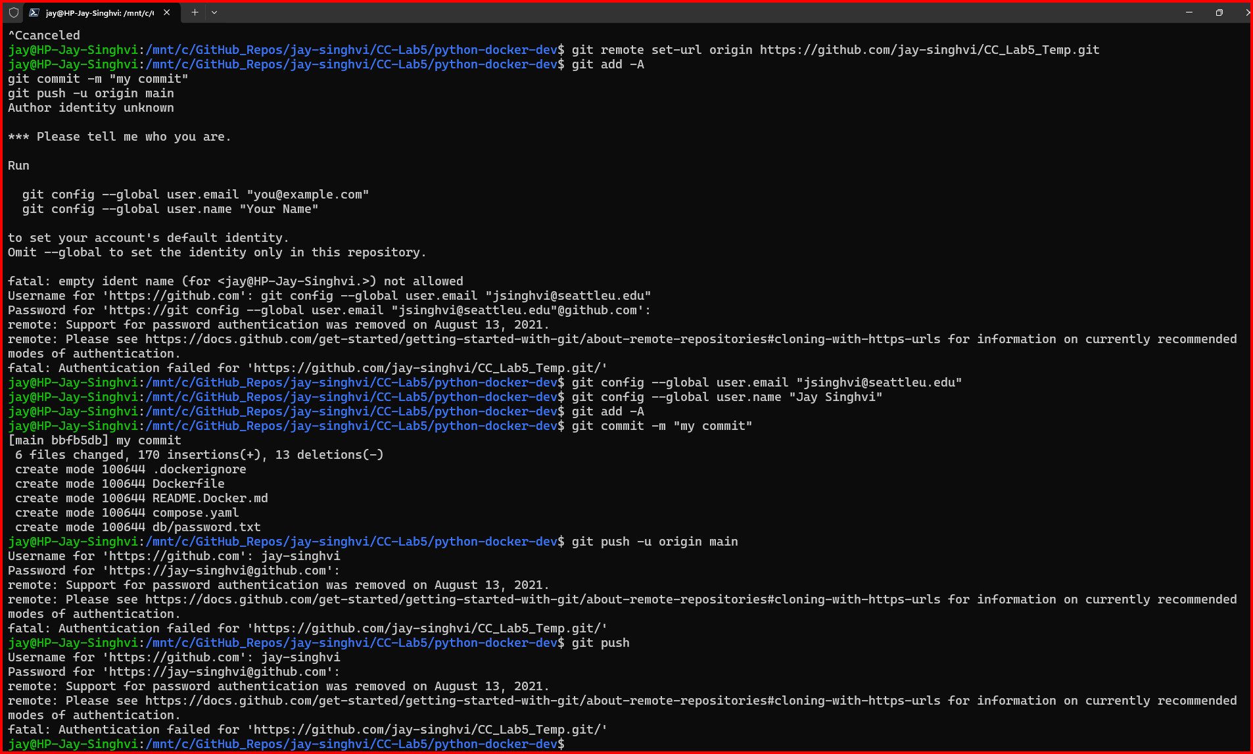

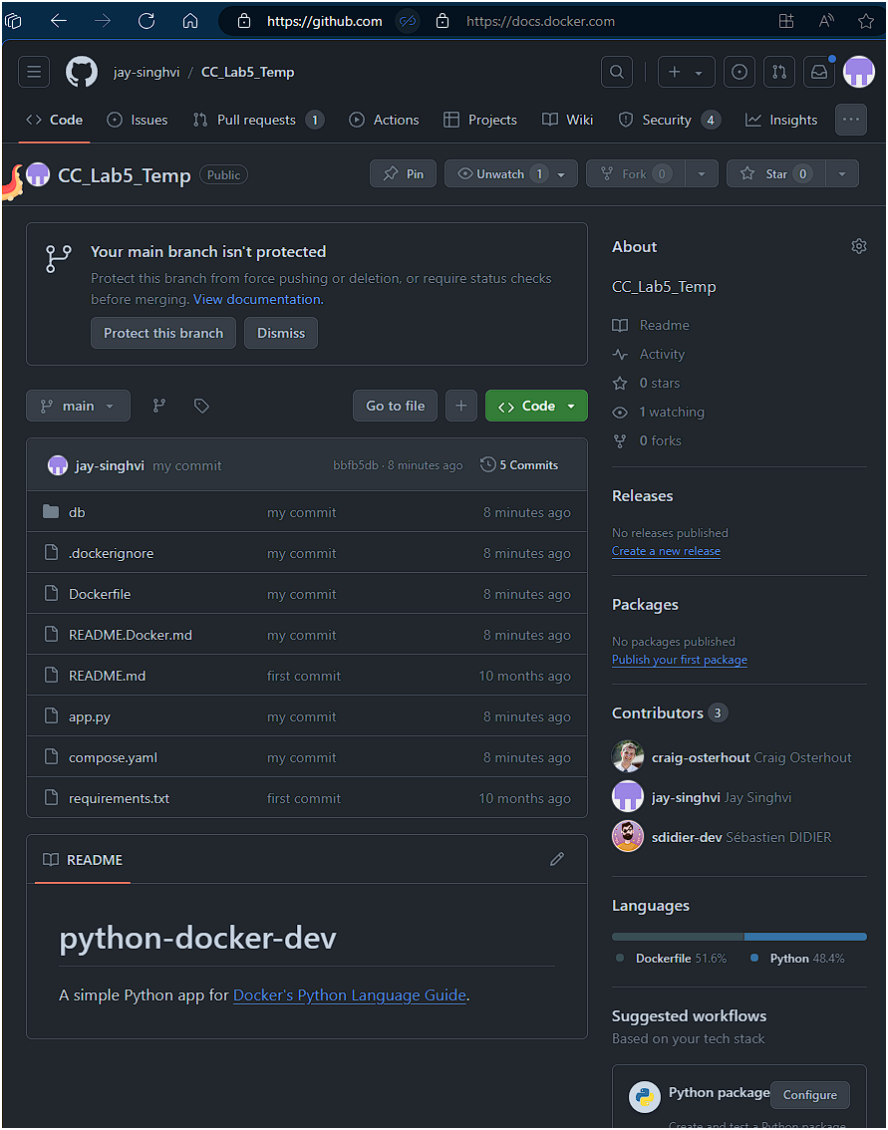

**Step two: Set up the workflow**

Set up your GitHub Actions workflow for building, testing, and pushing the image to Docker Hub.

1. Go to your repository on GitHub and then select the Actions tab.
2. Select set up a workflow yourself.

This takes you to a page for creating a new GitHub actions workflow file in your repository, under .github/workflows/main.yml by default.

1. In the editor window, copy and paste the following YAML configuration.

|  |
| --- |
| name: ci  on:  push:  branches:  - main  jobs:  build:  runs-on: ubuntu-latest  steps:  -  name: Checkout  uses: actions/checkout@v4  -  name: Login to Docker Hub  uses: docker/login-action@v3  with:  username: ${{ secrets.DOCKER_USERNAME }}  password: ${{ secrets.DOCKERHUB_TOKEN }}  -  name: Set up Docker Buildx  uses: docker/setup-buildx-action@v3  -  name: Build and push  uses: docker/build-push-action@v5  with:  context: .  push: true  tags: ${{ secrets.DOCKER_USERNAME }}/${{ github.event.repository.name }}:latest |

For more information about the YAML syntax used here, see Workflow syntax for GitHub Actions.

**Step three: Run the workflow**

Save the workflow file and run the job.

1. Select Commit changes... and push the changes to the main branch.

After pushing the commit, the workflow starts automatically.

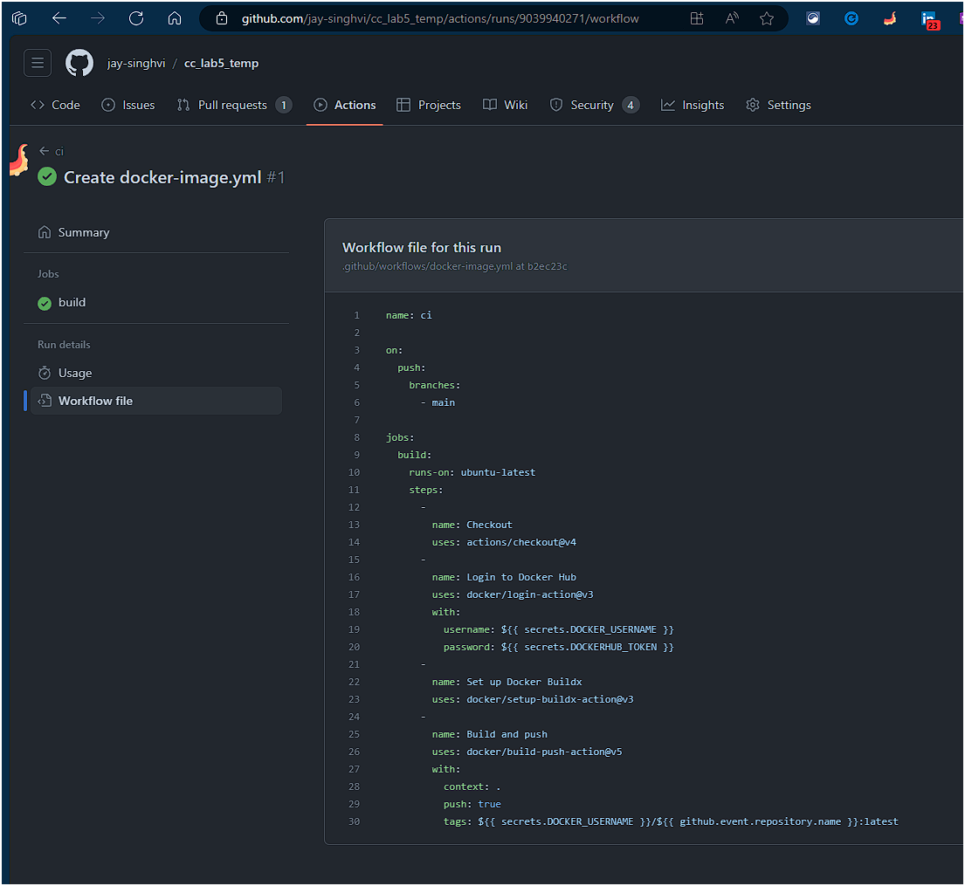

1. Go to the Actions tab. It displays the workflow.

Selecting the workflow shows you the breakdown of all the steps.

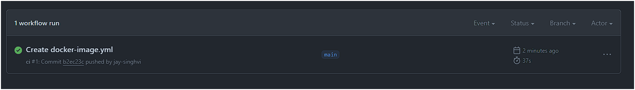

1. When the workflow is complete, go to your repositories on Docker Hub.

If you see the new repository in that list, it means the GitHub Actions successfully pushed the image to Docker Hub.

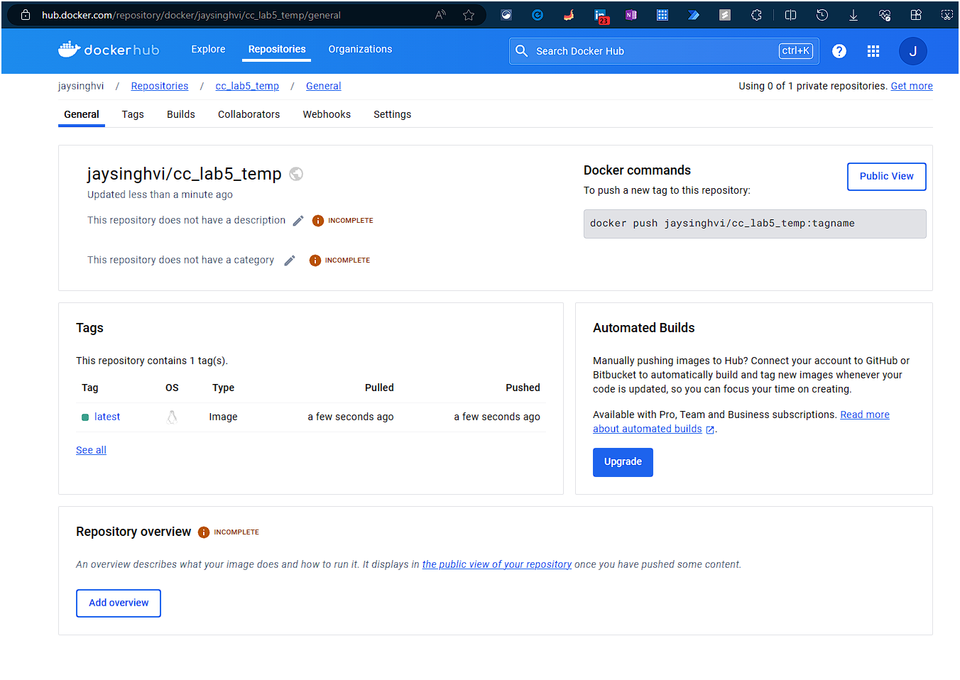

**Test your Python deployment**

**Prerequisites**

* Complete all the previous sections of this guide, starting with Containerize, a Python application.
* Turn on Kubernetes in Docker Desktop.

**Overview**

In this section, you'll learn how to use Docker Desktop to deploy your application to a fully featured Kubernetes environment on your development machine. This allows you to test and debug your workloads on Kubernetes locally before deploying.

**Create a Kubernetes YAML file**

In your python-docker-dev directory, create a file named docker-python-kubernetes.yaml. Open the file in an IDE or text editor and add the following contents. Replace DOCKER_USERNAME/REPO_NAME with your Docker username and the name of the repository that you created in Configure CI/CD for your Python application.

|  |
| --- |
| apiVersion: apps/v1  kind: Deployment  metadata:  name: docker-python-demo  namespace: default  spec:  replicas: 1  selector:  matchLabels:  service: flask  template:  metadata:  labels:  service: flask  spec:  containers:  - name: flask-service  image: DOCKER_USERNAME/REPO_NAME  imagePullPolicy: Always  env:  - name: POSTGRES_PASSWORD  value: mysecretpassword  ---  apiVersion: v1  kind: Service  metadata:  name: service-entrypoint  namespace: default  spec:  type: NodePort  selector:  service: flask  ports:  - port: 5000  targetPort: 5000  nodePort: 30001 |

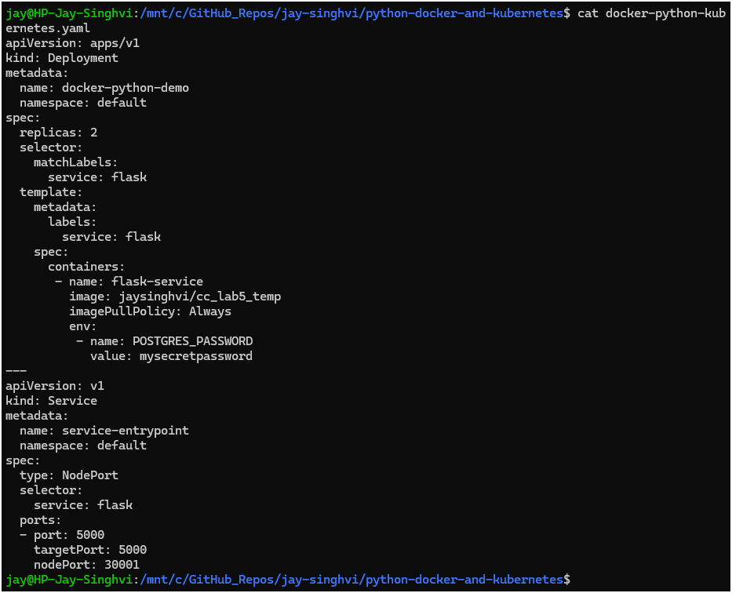

In this Kubernetes YAML file, there are two objects, separated by the ---:

* A Deployment, describing a scalable group of identical pods. In this case, you'll get just one replica, or copy of your pod. That pod, which is described under template, has just one container in it. The container is created from the image built by GitHub Actions in Configure CI/CD for your Python application.
* A NodePort service, which will route traffic from port 30001 on your host to port 5000 inside the pods it routes to, allowing you to reach your app from the network.

To learn more about Kubernetes objects, see the Kubernetes documentation.

**Deploy and check your application**

1. In a terminal, navigate to python-docker-dev and deploy your application to Kubernetes.

|  |
| --- |
| kubectl apply -f docker-python-kubernetes.yaml |

You should see output that looks like the following, indicating your Kubernetes objects were created successfully.

|  |
| --- |
| deployment.apps/docker-python-demo created  service/service-entrypoint created |

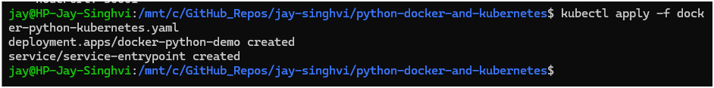

1. Make sure everything worked by listing your deployments.

|  |
| --- |
| kubectl get deployments |

Your deployment should be listed as follows:

|  |
| --- |
| NAME READY UP-TO-DATE AVAILABLE AGE  docker-python-demo 1/1 1 1 15s |



This indicates all one of the pods you asked for in your YAML are up and running. Do the same check for your services.

|  |
| --- |
| kubectl get services |

You should get output like the following.

|  |
| --- |
| NAME TYPE CLUSTER-IP EXTERNAL-IP PORT(S) AGE  kubernetes ClusterIP 10.96.0.1 <none> 443/TCP 23h  service-entrypoint NodePort 10.99.128.230 <none> 5000:30001/TCP 75s |

In addition to the default kubernetes service, you can see your service-entrypoint service, accepting traffic on port 30001/TCP.

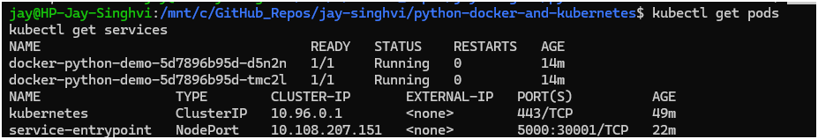



1. In a terminal, curl the service. Note that a database was not deployed in this example.

|  |
| --- |
| curl http://localhost:30001/  Hello, Docker!!! |

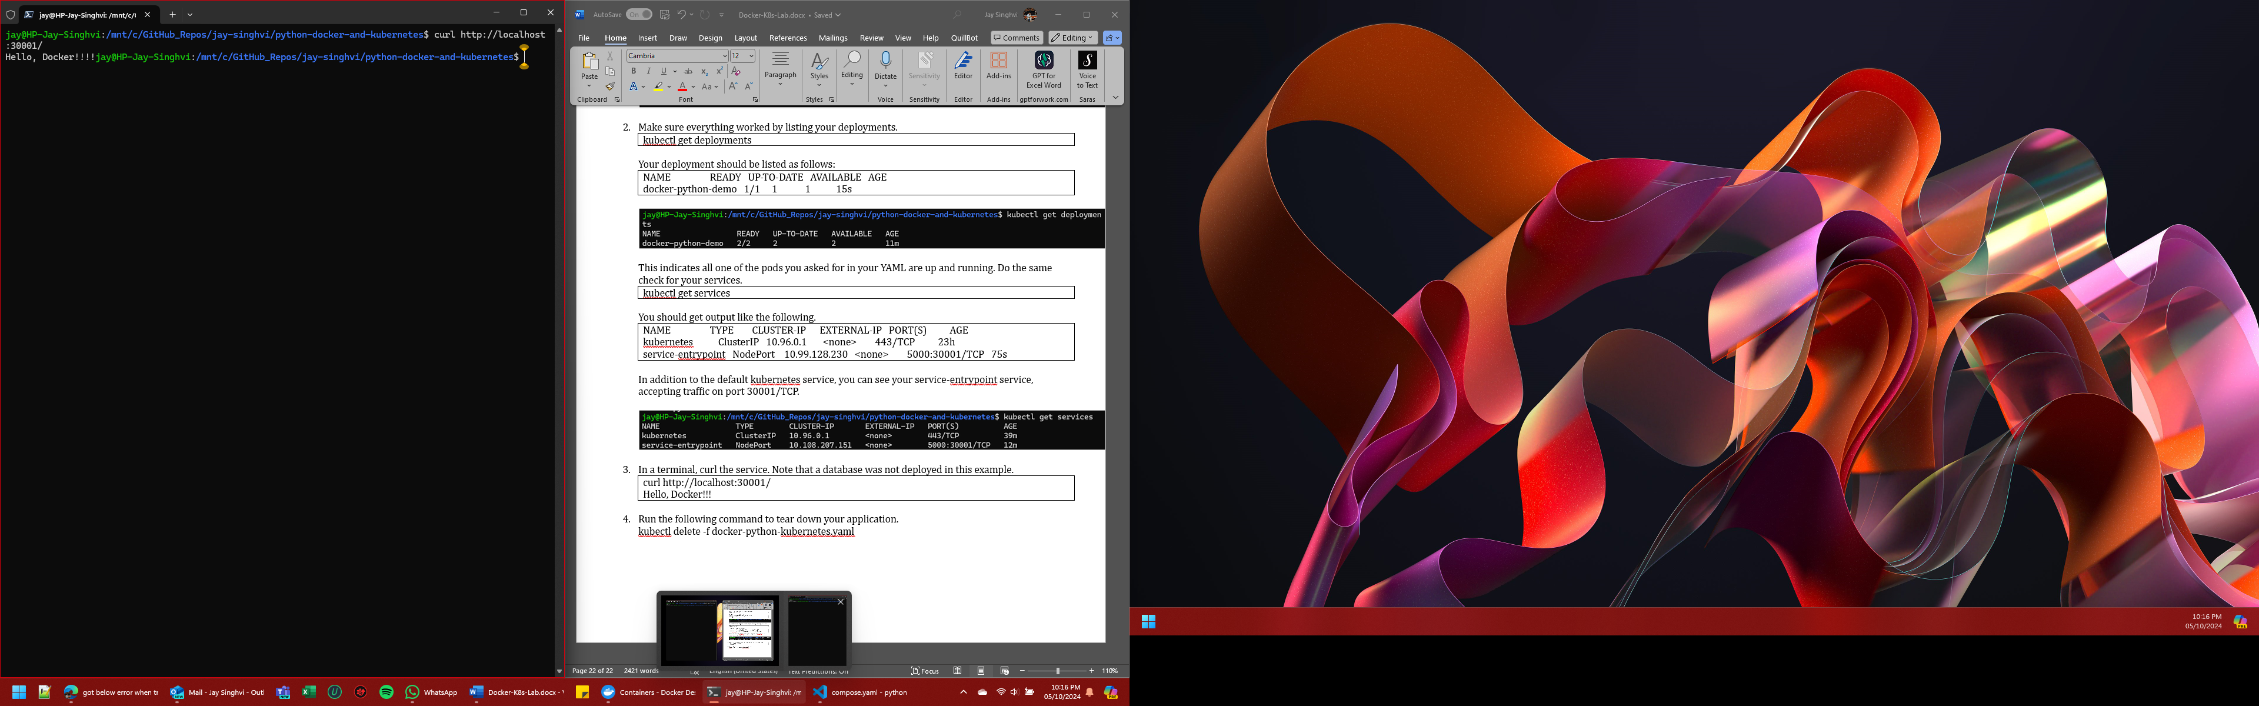

1. Run the following command to tear down your application.

|  |
| --- |
| kubectl delete -f docker-python-kubernetes.yaml |

